**PALS System**

White Box Testing

**April 21, 2016**

**Submitted By:**

Alvin

Andi Darmawan

Fakhria Nur Shabrina

Muhammad Farhan Mubarak

**Android Application**

Check Permission

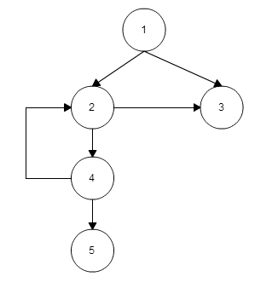

|  |  |
| --- | --- |
| **Path ID** | **Path** |
| **1.1** | 1, 2, 4, 2, 3 |
| **1.2** | 1, 2, 4, 2, 5 |
| **1.3** | 1, 3 |

**Test Cases**

|  |  |
| --- | --- |
| **Test to be Performed By:** | Muhammad Farhan Mubarak |
| **Test Type** | White Box – Basis Path |
| **Test Case Number** | W-1.1 |
| **Test Case Precondition** | Application installed in Android Platform 6.0 |
| **Item(s) to be tested** | |
| Check Permission-Path 1.1 | |
| **Specifications** | |
| **Input** | **Expected**  **Output/Result** |
| * android.os.Build.VERSION.SDK_INT = 23 * permission.ACCESS_FINE_LOCATION = PERMISSION_GRANTED | return true |

|  |  |
| --- | --- |
| **Test to be Performed By:** | Muhammad Farhan Mubarak |
| **Test Type** | White Box – Basis Path |
| **Test Case Number** | W-1.2 |
| **Test Case Precondition** | Application installed in android platform 6.0 |
| **Item(s) to be tested** | |
| Check Permission-Path 1.2 | |
| **Specifications** | |
| **Input** | **Expected**  **Output/Result** |
| * android.os.Build.VERSION.SDK_INT = 23 * permission.ACCESS_FINE_LOCATION = PERMISSION_DENIED | return false |

|  |  |
| --- | --- |
| **Test to be Performed By:** | Muhammad Farhan Mubarak |
| **Test Type** | White Box – Basis Path |
| **Test Case Number** | W-1.1 |
| **Test Case Precondition** | Application installed in Android Platform 6.0 |
| **Item(s) to be tested** | |
| Check Permission-Path 1.1 | |
| **Specifications** | |
| **Input** | **Expected**  **Output/Result** |
| * android.os.Build.VERSION.SDK_INT = 23 * permission.ACCESS_FINE_LOCATION = PERMISSION_GRANTED | return true |

Get Permission

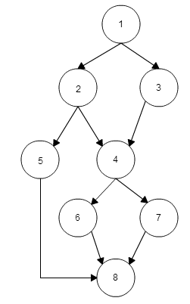

|  |  |
| --- | --- |
| **Path ID** | **Path** |
| **2.1** | 1, 2, 4, 6, 8 |
| **2.2** | 1, 2. 4, 7, 8 |
| **2.3** | 1, 2, 5, 8 |
| **2.4** | 1,3,4,6,8 |
| **2.5** | 1,3,4,7,8 |

**Test Cases**

|  |  |
| --- | --- |
| **Test to be Performed By:** | Muhammad Farhan Mubarak |
| **Test Type** | White Box – Basis Path |
| **Test Case Number** | W-2.1 |
| **Test Case Precondition** | Check Permission return false, Devices already installed Google Play Services |
| **Item(s) to be tested** | |
| Get Permission-Path 2.1 | |
| **Specifications** | |
| **Input** | **Expected**  **Output/Result** |
| * Check Permission return false * permission.ACCESS_FINE_LOCATION = PERMISSION_GRANTED * isGooglePlayServicesAvailable = .SUCCESS | Activity continue running |

|  |  |
| --- | --- |
| **Test to be Performed By:** | Muhammad Farhan Mubarak |
| **Test Type** | White Box – Basis Path |
| **Test Case Number** | W-2.2 |
| **Test Case Precondition** | Check Permission return false, Devices not installed Google Play Servics |
| **Item(s) to be tested** | |
| Get Permission-Path 2.2 | |
| **Specifications** | |
| **Input** | **Expected**  **Output/Result** |
| * Check Permission return false * permission.ACCESS_FINE_LOCATION = PERMISSION_GRANTED * isGooglePlayServicesAvailable = .SUCCESS | Activity closed |

|  |  |
| --- | --- |
| **Test to be Performed By:** | Muhammad Farhan Mubarak |
| **Test Type** | White Box – Basis Path |
| **Test Case Number** | W-2.3 |
| **Test Case Precondition** | Check Permission return false |
| **Item(s) to be tested** | |
| Get Permission-Path 2.3 | |
| **Specifications** | |
| **Input** | **Expected**  **Output/Result** |
| * Check Permission return false * permission.ACCESS_FINE_LOCATION = PERMISSION_DENIED | Display ”Permission Rejected” Dialog then Application close automatically |

|  |  |
| --- | --- |
| **Test to be Performed By:** | Muhammad Farhan Mubarak |
| **Test Type** | White Box – Basis Path |
| **Test Case Number** | W-2.4 |
| **Test Case Precondition** | Check Permission return true, Devices already installed Google Play Services |
| **Item(s) to be tested** | |
| Get Permission-Path 2.4 | |
| **Specifications** | |
| **Input** | **Expected**  **Output/Result** |
| * Check Permission return true * isGooglePlayServicesAvailable = .SUCCESS | Activity Continue Running |

|  |  |
| --- | --- |
| **Test to be Performed By:** | Muhammad Farhan Mubarak |
| **Test Type** | White Box – Basis Path |
| **Test Case Number** | W-2.5 |
| **Test Case Precondition** | Check Permission return true, Devices not installed Google Play Services |
| **Item(s) to be tested** | |
| Get Permission-Path 2.5 | |
| **Specifications** | |
| **Input** | **Expected**  **Output/Result** |
| * Check Permission return true * isGooglePlayServicesAvailable != .SUCCESS | Activity Closed |